Continuous data
# Source: AI Source: Provided by: [Data Path: Persons Table -> ID Column: 1, Name_En Column: Motasem Essam] -> From: [Chatgpt (GPT‑5 Mini)] on [12/10/2025]
Continuous data is another type of quantitative data, but unlike discrete data, it can take any value within a range and is usually measured, not counted.

Definition:
# Source: AI Source: Provided by: [Data Path: Persons Table -> ID Column: 1, Name_En Column: Motasem Essam] -> From: [Chatgpt (GPT‑5 Mini)] on [12/10/2025]
Continuous data = numerical data that can take any value (including fractions or decimals) within a range.

Key Features:
# Source: AI Source: Provided by: [Data Path: Persons Table -> ID Column: 1, Name_En Column: Motasem Essam] -> From: [Chatgpt (GPT‑5 Mini)] on [12/10/2025]
- Measured, not counted.
- Can take any value in an interval.
- Often includes decimals or fractions.

Examples of Continuous Data:
# Source: AI Source: Provided by: [Data Path: Persons Table -> ID Column: 1, Name_En Column: Motasem Essam] -> From: [Chatgpt (GPT‑5 Mini)] on [12/10/2025]
- Height of students → 160.5 cm, 170.2 cm, 175.8 cm
- Temperature → 36.6°C, 37.2°C
- Weight → 55.3 kg, 68.7 kg
- Time → 12.5 seconds, 15.75 seconds

Contrast with Discrete Data:
# Source: AI Source: Provided by: [Data Path: Persons Table -> ID Column: 1, Name_En Column: Motasem Essam] -> From: [Chatgpt (GPT‑5 Mini)] on [12/10/2025]
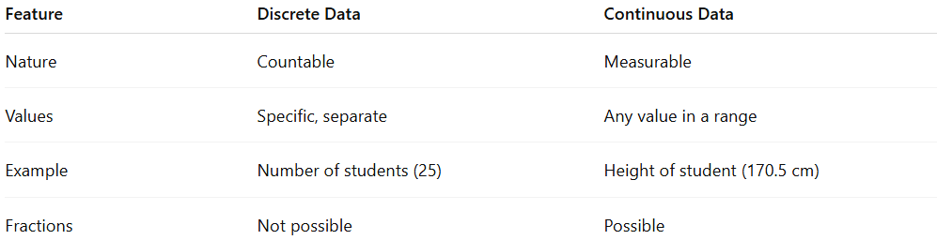
Feature | Discrete Data | Continuous Data
Nature | Countable | Measurable
Values | Specific, separate | Any value in a range
Example | Number of students (25) | Height of student (170.5 cm)
Fractions | Not possible | Possible

✅ Summary:
# Source: AI Source: Provided by: [Data Path: Persons Table -> ID Column: 1, Name_En Column: Motasem Essam] -> From: [Chatgpt (GPT‑5 Mini)] on [12/10/2025]
- Discrete: “How many?” → Countable whole numbers
- Continuous: “How much?” → Measurable, can have fractions

